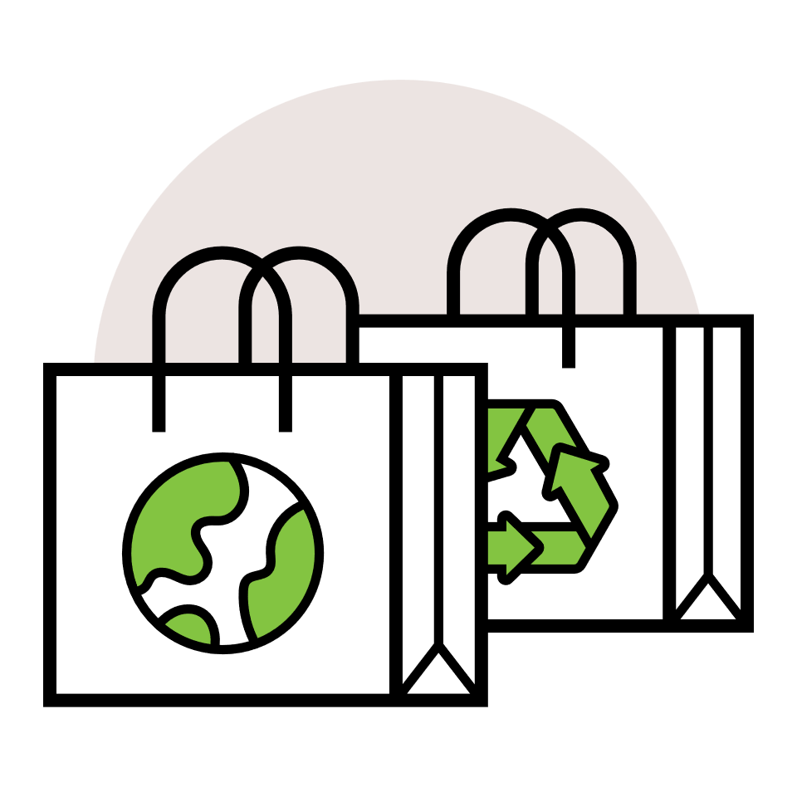

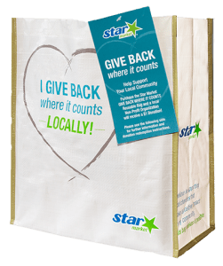

GIVE BACK WHERE IT COUNTS  
REUSABLE BAG PROGRAM

Launch Day Email

& Social Post

**SUBJECT:** Launch day for the Star Market GIVE BACK WHERE IT COUNTS Reusable Bag  
Program partnership!

**PREVIEW TEXT:** Our partnership with the Star Market GIVE BACK WHERE IT COUNTS Reusable Bag Program starts today.

Good morning,

Today is the launch day for our Star Market GIVE BACK WHERE IT COUNTS Reusable Bag Program partnership! Throughout [*month*], when you purchase a reusable GIVE BACK WHERE IT COUNTS Reusable Bag for $2.50 at the Star Market located at [*address(es) of selected store(s)*], $1 will be donated to [*name of organization*].

During this monthlong partnership, our goal is to sell [*goal of bags bought, e.g., 200*] bags, which is equivalent to $[*insert donation equivalent, e.g., $200*] donated. We are confident that with the help of our dedicated supporters we can reach this goal.

To make the most of this opportunity, we strongly encourage you to share this news with your friends and family. Make sure everyone knows to look for GIVE BACK WHERE IT COUNTS Reusable Bags on display racks in our selected store(s) this month.

For more information, please visit [starmarket.2givelocal.com](https://starmarket.2givelocal.com/).

Thank you for your support!

Best,

[*Signature*]



**Today, we start benefiting from the Star Market GIVE BACK WHERE IT COUNTS Reusable Bag Program! This month, our organization will receive a $1 donation for every $2.50 reusable GIVE BACK WHERE IT COUNTS Reusable Bag purchased at the Star Market(s) located at [*store* *address(es)*].**

share with your followers