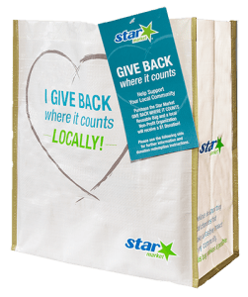
GIVE BACK WHERE IT COUNTS REUSABLE BAG PROGRAM

Announcement Email

SUBJECT LINE: We’ve been selected by the Star Market GIVE BACK WHERE IT COUNTS Reusable Bag Program!
PREVIEW TEXT: For all of [Month], we receive $1 for every GIVE BACK WHERE IT COUNTS Reusable Bag purchased at Star Market!

Dear [Staff/Board/Volunteers/Supporters],

We are so excited to share that [organization] has been selected to benefit from Star Market’s GIVE BACK WHERE IT COUNTS Reusable Bag Program, which makes it easy for shoppers to contribute to their local communities.

For the month of [month], whenever a $3.00 GIVE BACK WHERE IT COUNTS Reusable Bag is purchased at the Star Market located at [location], $1 will be donated to [organization]. This is a great way to broaden awareness and help our cause.

The Star Market GIVE BACK WHER IT COUNTS Reusable Bag Program, which launched in March 2019, is a reusable bag program that facilitates community support with the goal to make a difference in the communities where shoppers live and work.

Let’s get started! Share the news with friends and family. Call, send emails, and post on social media. The more people who purchase the GIVE BACK WHERE IT COUNTS Reusable Bag in [month], the greater the donation we will receive!
To learn more about this program, please visit starmarket.2givelocal.com.
Best,

[Signature]

