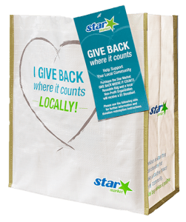
GIVE BACK WHERE IT COUNTS REUSABLE BAG PROGRAM

Thank Your Supporters Email & Social Post

DOWNLOAD IMAGES
SUBJECT: Thank you for your support!

Hello,

Through the Star Market GIVE BACK WHERE IT COUNTS Reusable Bag Program, we received $[money raised] in donations from bag sales in the month of [benefiting month]!

We extend a HUGE thank you for your participation and support during our benefiting month of the Star Market GIVE BACK WHERE IT COUNTS Reusable Bag Program. Whether you bought a bag or helped spread the word, we couldn’t have done this without you. The money generated will help us to [share what you’ll do with the donations]. Thank you again for making this a fun and successful experience for [name of
the organization].

But guess what? We’re not done! Anyone can continue to support [name of the organization] by visiting any Star Market, purchasing the GIVE BACK WHERE IT COUNTS Reusable Bag and using the attached Giving Tag to send a $1 donation to us any time throughout the year!

Share With Your Followers
Thank you! We raised $[donation amount] through the Star Market GIVE BACK WHERE IT COUNTS Reusable Bag Program! Guess what? You can still support us by visiting any Star Market, purchasing the GIVE BACK WHERE IT COUNTS Reusable Bag and using the attached Giving Tag to send a $1 donation to us any time throughout the year.

starmarket.2givelocal.com

